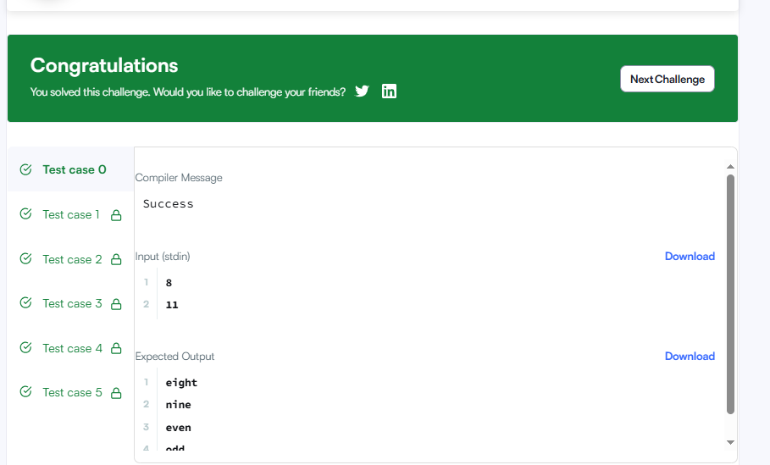

CODE-

#include <stdio.h>

int main() {
int a, b;
scanf("%d %d", &a, &b);

char *words[] = {"one", "two", "three", "four", "five",
"six", "seven", "eight", "nine"};

for (int i = a; i <= b; i++) {
if (i <= 9) {
printf("%s\n", words[i - 1]);
}
else if (i % 2 == 0) {
printf("even\n");
}
else {
printf("odd\n");
}
}

return 0;
}

LINK-

https://www.hackerrank.com/challenges/for-loop-in-c/problem

